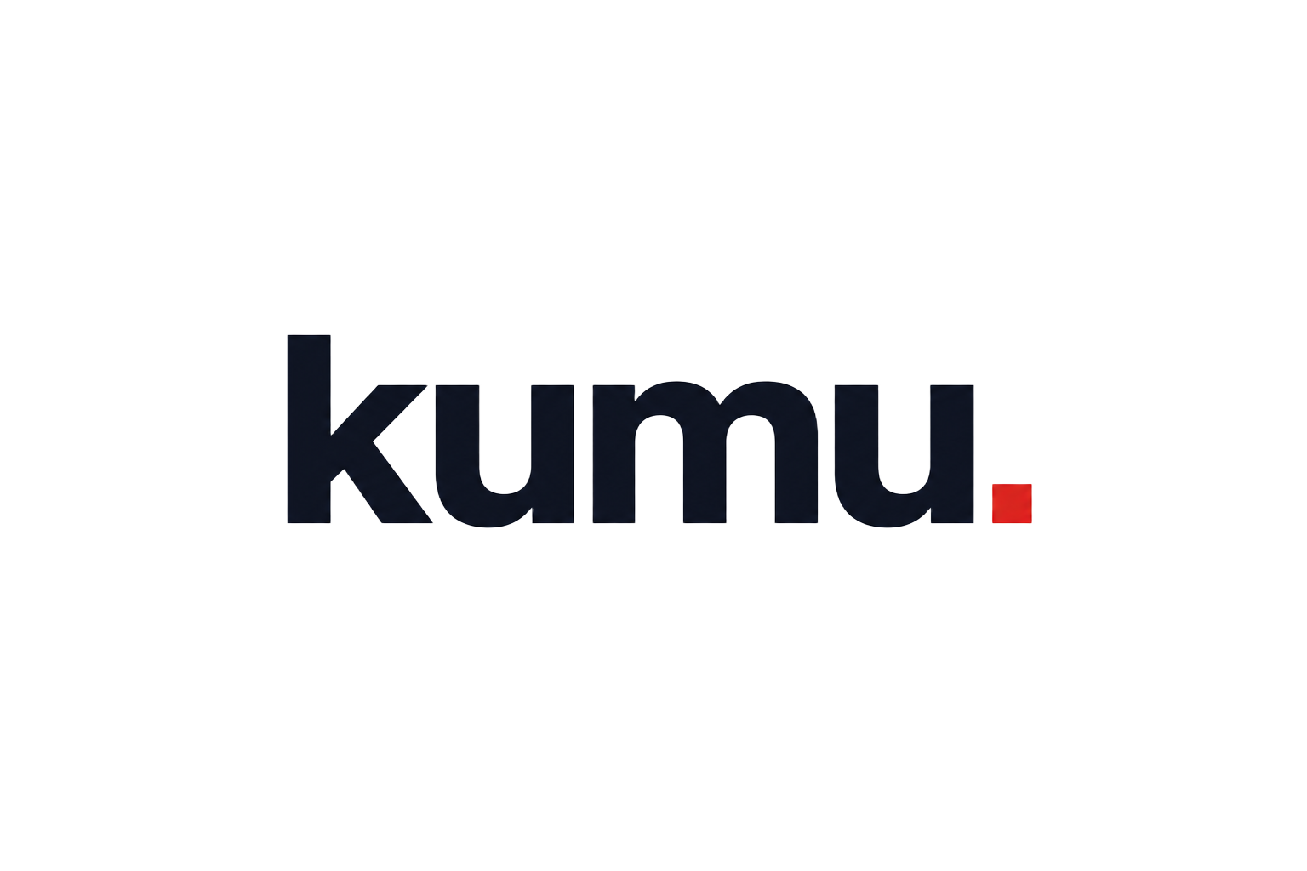
CAPABILITIES · 2026
Document Title.
A short subtitle that sets up the document — one sentence is plenty.

Prepared by Kumu Agency · Vancouver, BC · kumuagency.com

SECTION 01

Hello.
We help forward-thinking brands connect better with their customers. Strategy without craft is a deck. Craft without strategy is decoration. We insist on both.
OUR MANTRA

We wake up curious

Be deeply curious
Questions before answers.

Team with clients
Build with, not deliver to.

Make it measurable
Designed for outcomes in the data.

Sweat the craft
Strategy and craft, never one without.
WHAT WE DO

Four practices, one team
- Strategy & Transformation — the power of inside-out thinking.
- Experience & Design — the customer sees everything.
- Campaigns, Ads & PR — performance marketing & ROI.
- Platform & Apps — build it and they will come.
CASE STUDY

Project Name
Cause-led platform · 6-month build · global audience

Challenge
One short paragraph framing the brief and the stakes.

Solution
What we did — discovery, strategy, design, build — in plain language.

Outcome
The result, with numbers when possible.
BY THE NUMBERS
20+.  Years building | 4.  Practices | Pacific.  Edge of the ocean

